Department of Management Studies (MBA)
Academic Year 2025-26
Seminar Report on “I Am the Change: Learning Today, Leading Tomorrow”

- Event Title: “I Am the Change: Learning Today, Leading Tomorrow”
- Date: 5th May 2026
- Conduction Duration: 2 Hour
- Venue: E’ Buiding, MBA Dept, SITRC.
- Resource Person: Mr. Dipakkumar S. Patil
(Founder & CEO: DiShadows and Founder & Director: HealthKattaa Services Pvt. Ltd.)
- Coordinator: Prof. Pratiksha Bhujbal

Objective:
- To inspire students to take initiative and become proactive leaders.
- To emphasize the importance of continuous learning for future leadership.
- To develop a mindset of self-responsibility and positive change among students.
- To guide students in aligning personal growth with professional success.

About the Program:
The Department of Management Studies (MBA) organized an insightful guest lecture on “I Am the Change: Learning Today, Leading Tomorrow” for MBA students on 5th May 2026.
The session was conducted by Mr. Dipakkumar S. Patil, a successful entrepreneur and visionary leader, currently serving as Founder & CEO of DiShadows and Founder & Director of HealthKattaa Services Pvt. Ltd. He shared his valuable experiences and journey, motivating students to become change-makers in their personal and professional lives.
During the session, he emphasized that real change begins with self-awareness, continuous learning, and a willingness to step out of one’s comfort zone. He highlighted the importance of leadership qualities, adaptability, and innovation in today’s dynamic business environment.
Key highlights of the session included:
- Importance of self-leadership and personal responsibility
- Role of continuous learning in career growth
- Developing a proactive and positive mindset
- Leadership skills for future managers
- Real-life entrepreneurial insights and experiences
Mr. Patil engaged students through real-life examples, motivational stories, and interactive discussions. He encouraged students to take initiative, believe in their abilities, and strive to create a positive impact in society.
The session was highly interactive, with enthusiastic participation from students. It concluded with a Q&A session where students clarified their doubts and gained practical insights.

Outcome:
- Students were motivated to take responsibility for their personal and professional growth.
- Participants developed a better understanding of leadership and self-development.
- Students gained insights into entrepreneurship and real-world challenges.
- The session enhanced confidence, motivation, and goal-oriented thinking among students.

Glimpse of the Day
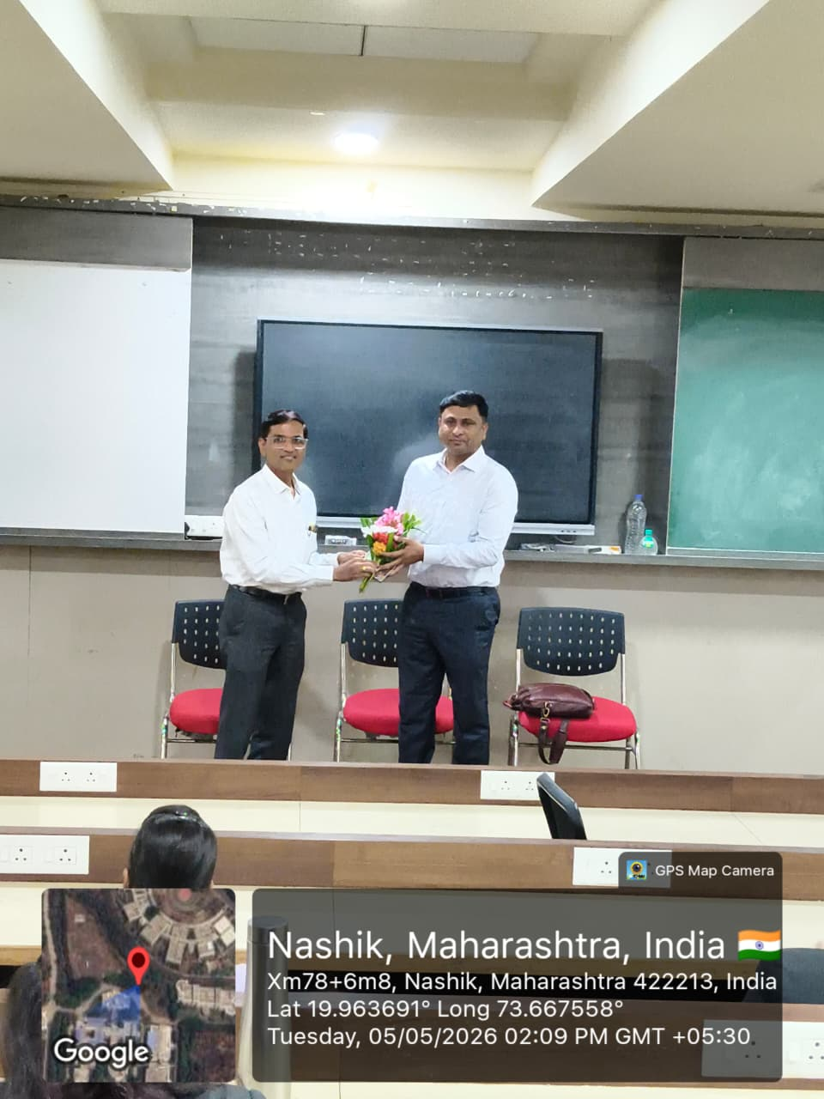

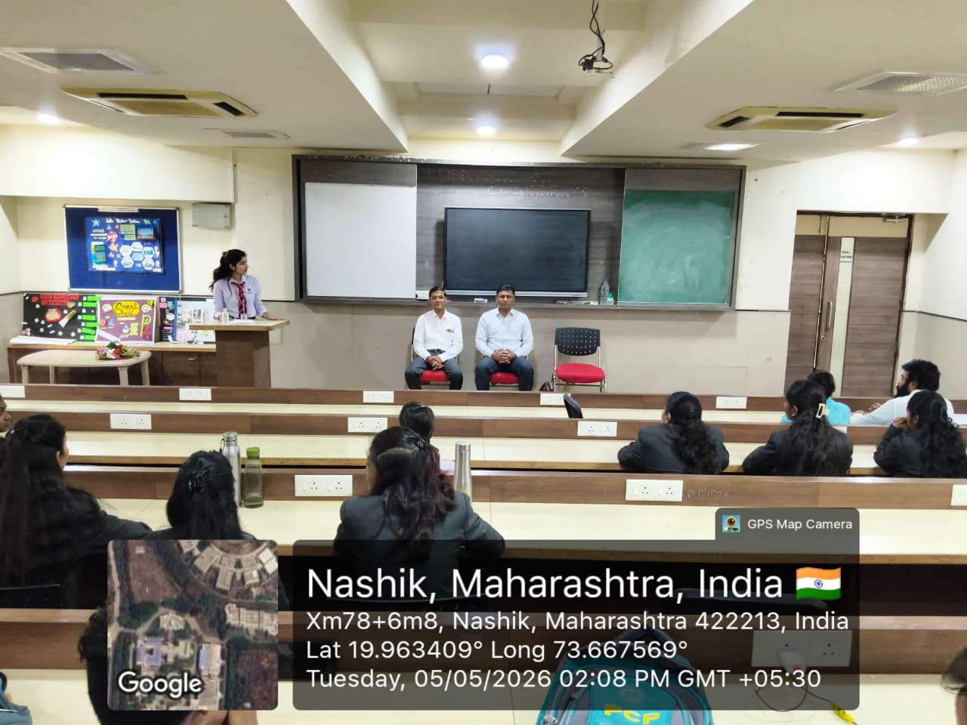

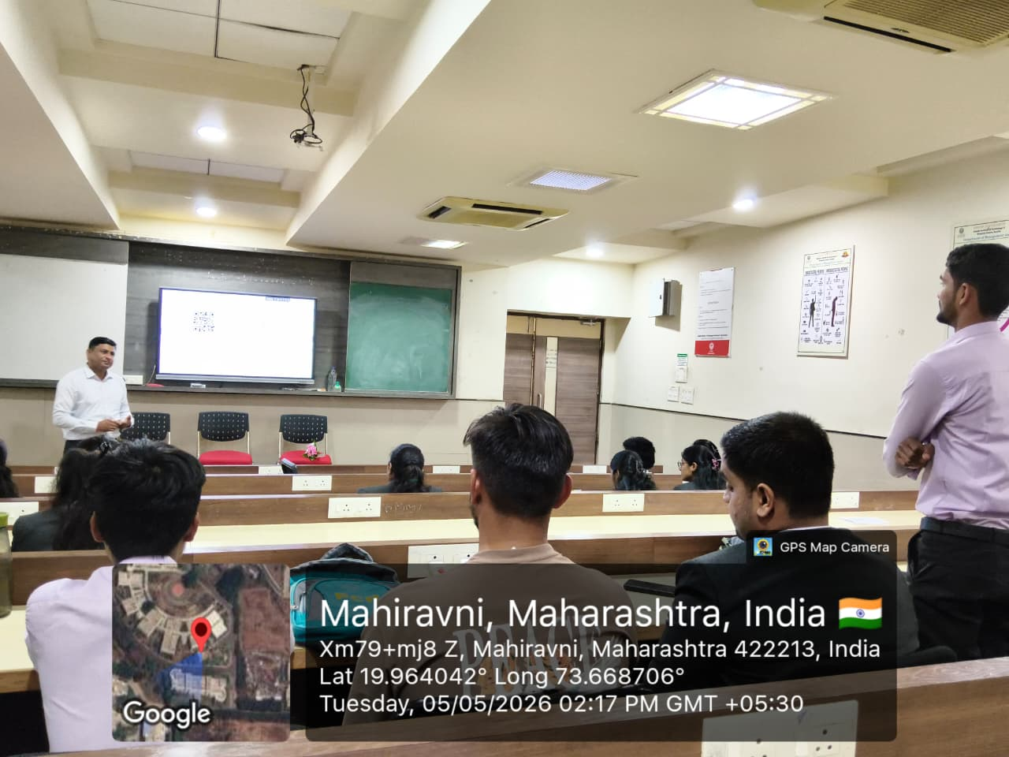


Prof. Pratiksha Bhujbal Dr. Abhay Bora Dr. Amol Potgantwar
Coordinator HOD, Dept of MBA Principal, SITRC

