Department of Management Studies (MBA)
Academic Year 2025-26
Report on “Hands-on Session on Power BI”

- Event Title: “Hands-on Session on Power BI”
- Date: 27th April 2026
- Conduction Duration: Full Day
- Venue: E’ Buiding, MBA Dept, SITRC.
- Resource Person: Prof. Hiralal Solunke
- Coordinator: Prof. Pratiksha Bhujbal

Objective:
- To provide practical knowledge of Power BI for data visualization and analytics.
- To enhance students' skills in data-driven decision-making.
- To bridge the gap between theoretical learning and industry requirements.
- To introduce students to business intelligence tools widely used in organizations.
About the Program:
The Department of Management Studies (MBA), Sandip Institute of Technology and Research Centre, Nashik, organized a Hands-on Session on Power BI for MBA students.
The session was conducted by Prof. Hiralal Solunke, an expert in data analytics and business intelligence tools. The session focused on providing practical exposure to Power BI, one of the most widely used tools for data visualization and reporting in the industry.
During the session, Prof. Solunke demonstrated how raw data can be transformed into meaningful insights using Power BI dashboards and reports. He explained the importance of data analytics in modern business environments and how organizations rely on data for strategic decision-making.

Key Highlights of the Session:
- Introduction to Power BI interface and features
- Data import and data cleaning techniques
- Creating interactive dashboards and reports
- Use of charts, graphs, and visualization tools
- Data modeling and relationships
- Real-time business case examples using Power BI
- Importance of data analytics in managerial decision-making
He emphasized that in today’s competitive environment, having analytical and technical skills such as Power BI gives students a significant advantage in the job market. He also guided students on how to build projects and portfolios using data visualization tools.
The session was highly interactive, where students actively worked on their laptops and followed step-by-step demonstrations. Queries raised by students were addressed with practical examples, making the session engaging and insightful.

Outcome:
- Students gained hands-on experience in using Power BI.
- Participants understood the importance of data visualization in business.
- Students developed skills in creating dashboards and reports.
- The session enhanced students’ readiness for data-driven roles in industry.

Glimpse of the Day
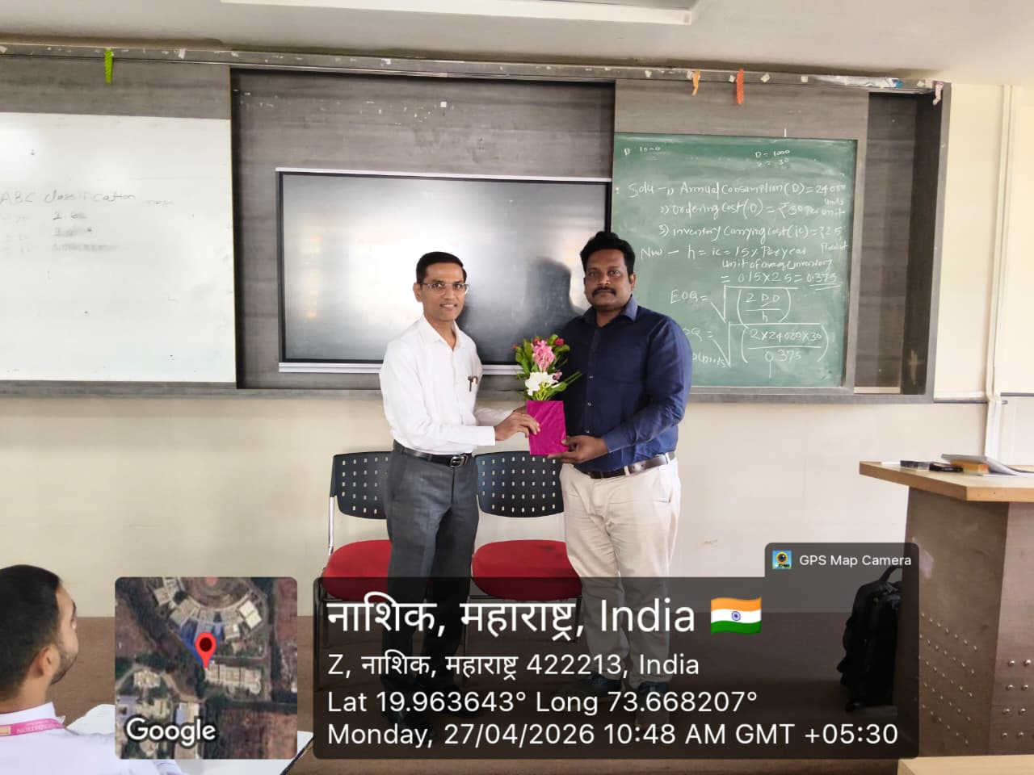
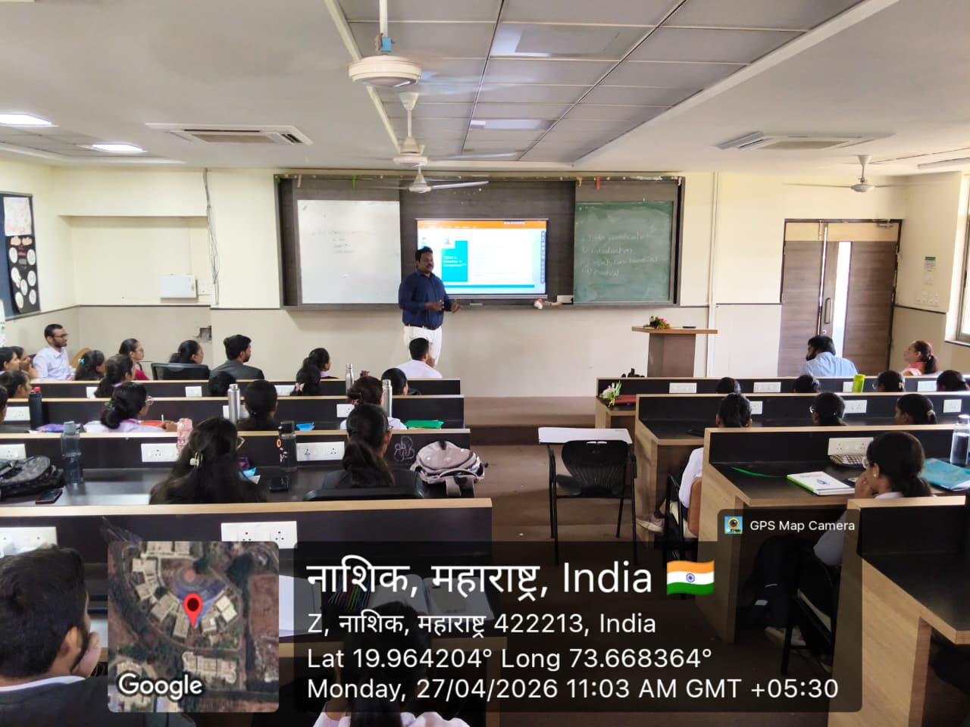
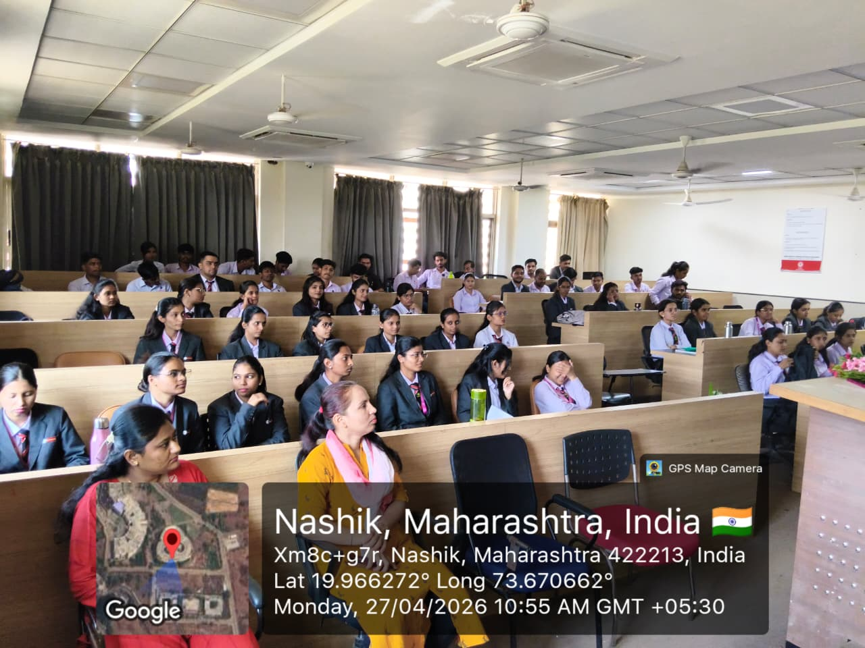

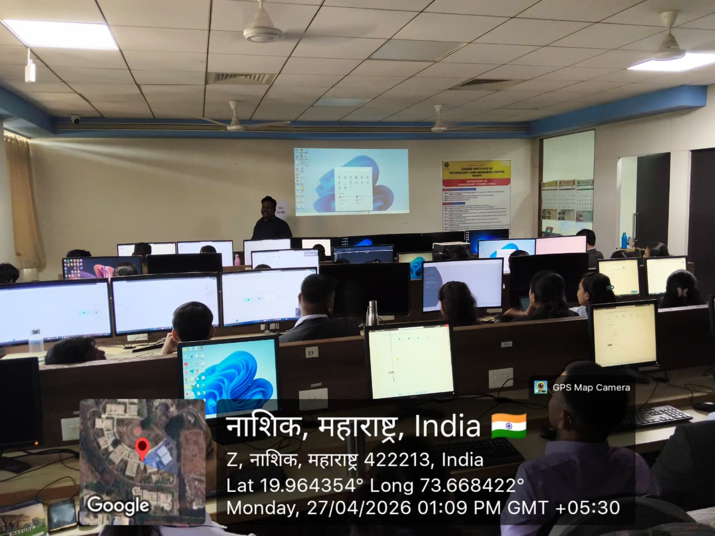


Prof. Pratiksha Bhujbal Dr. Abhay Bora Dr. Amol Potgantwar
Coordinator HOD, Dept of MBA Principal, SITRC

