Department of Management Studies (MBA)
Academic Year 2025-26
Seminar Report on “Awareness Program on Self-esteem & Self-image”

- Event Title: “Awareness Program on Self-esteem & Self-image”
- Date: 29th April 2026
- Conduction Duration: 1 Hour
- Venue: E’ Buiding, MBA Dept, SITRC.
- Resource Person: Ms. Shalmali Shetty (Soft Skill Trainer),
Inner Wheel Club of Gen-Next Nashik (International NGO)
- Coordinator: Prof. Pratiksha Bhujbal

Objective:
- To create awareness about the importance of self-esteem and self-image among students.
- To help students understand how self-perception influences personal and professional growth.
- To develop confidence and a positive mindset among MBA students.
- To guide students in improving their communication, personality, and emotional intelligence.
About the Program:
The Department of Management Studies (MBA) organized an insightful guest lecture on “Awareness Program on Self-esteem & Self-image” for MBA students on 29th April 2026.
The session was conducted by Ms. Shalmali Shetty, a renowned Soft Skill Trainer associated with the Inner Wheel Club of Gen-Next Nashik. She delivered an engaging and interactive session focusing on personal development and self-awareness.
During the session, she emphasized that self-esteem plays a crucial role in shaping an individual’s personality, decision-making ability, and overall success. She explained how self-image influences confidence levels, communication skills, and leadership qualities.
Key highlights of the session included:
- Understanding the concept of self-esteem and self-image
- Importance of positive thinking and self-belief
- Techniques to overcome self-doubt and fear
- Role of body language and communication in personality development
- Building confidence for career growth and professional success
Ms. Shetty used real-life examples, practical exercises, and interactive activities to engage students effectively. She encouraged students to identify their strengths, work on their weaknesses, and maintain a positive attitude in both personal and professional life.
The session was highly interactive, with students actively participating in discussions and activities. The program concluded with a Q&A session where students clarified their doubts and gained valuable insights.

Outcome:
- Students developed a better understanding of self-esteem and its importance.
- Participants gained confidence and learned techniques for self-improvement.
- Students became more aware of their strengths and areas of development.
- The session enhanced students’ interpersonal and communication skills.

Glimpse of the Day

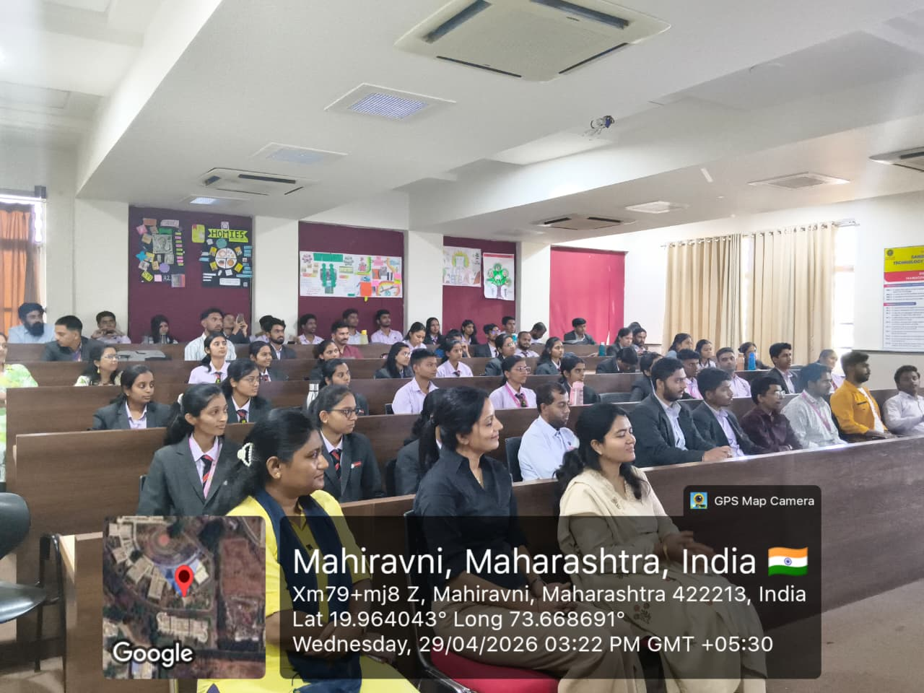

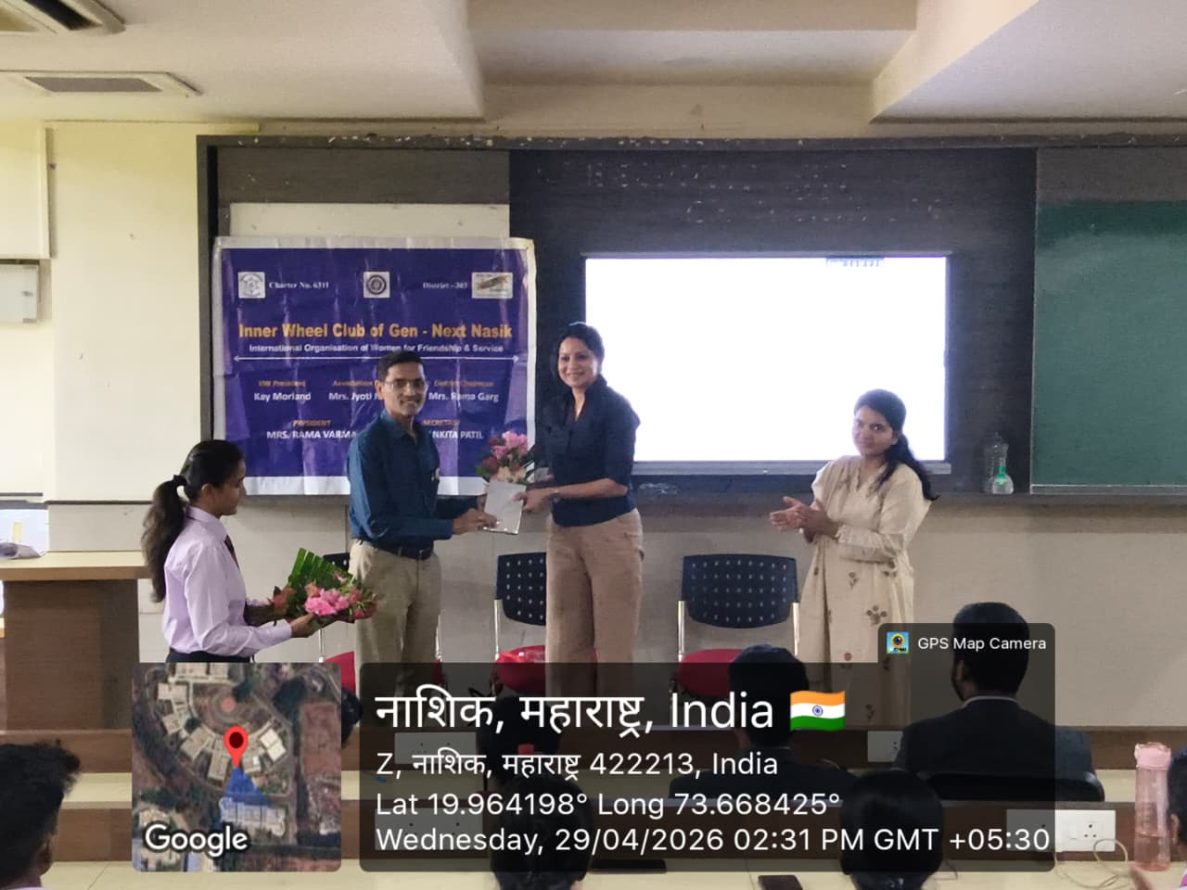
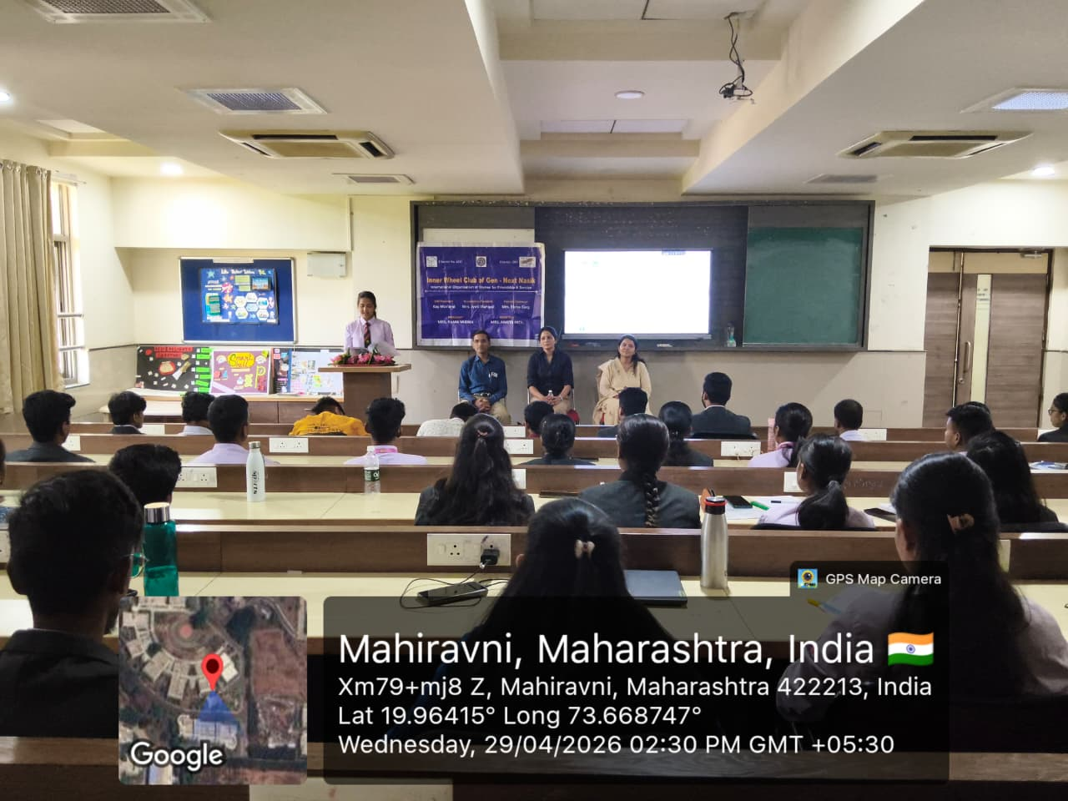


Prof. Pratiksha Bhujbal Dr. Abhay Bora Dr. Amol Potgantwar
Coordinator HOD, Dept of MBA Principal, SITRC

